Redstone Documentation
This documentation explains all the pages and their functionalities for the Redstone EyeQ application.
- Running the application in current PC
Double-click on the desktop shortcut named ABIUnifiedApp to run the application.
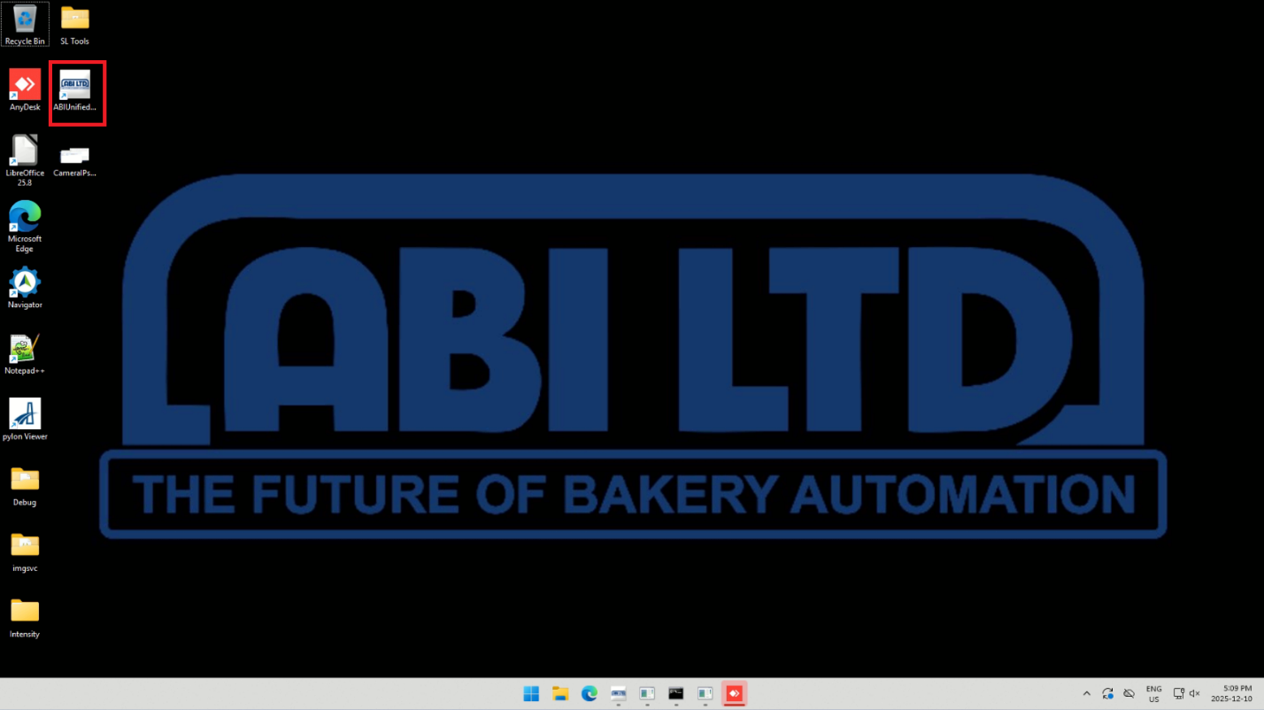

- Accessing the Application from Another PC on the LAN
In this document we will be using the words LAN and nodes in several places.
LAN (Local area network): A LAN is a network of computers connected together in the same network or workspace.
Node: A node is a specific workstation or processing point in the production line.
The Redstone EyeQ application runs on one node (the "host"), but other computers in the same office/factory can access it by typing the host's IP address into a web browser. All these computers are connected via the same LAN.

Open a web browser and enter the host machine’s LAN IP and port. If you want to access all three, just open three tabs and put the following urls in the tabs. We suggest that you bookmark or save the links as favourite to easily access the next time when you run the browser.
- Depositing - http://172.18.50.41:5000
- Proofer - http://172.18.50.42:5000
- Post Bake - http://172.18.50.40:5000
Please find the screenshot showing Depositing being accessed by browser from another computer in the same LAN.
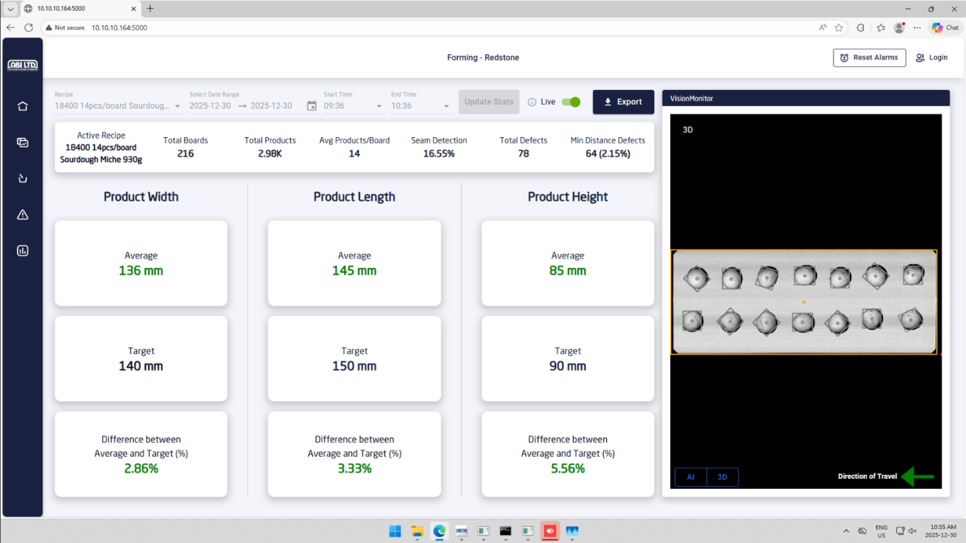
- Home
The home page of the application shows the following information.
  - Active Recipe that is running in that specific node.
  - The number of boards, total products, average products per board, total defects for the last hour.
  - Based on the setting and node, Seam detection (%) and Minimum distance defects (%) are also available for the last hour. As the screenshot below is for the Depositing node, we can see both of these values.
  - The measurements of the product (width, length and height) are also shown in the home page. The average, target and the difference in percentage between the average and the target are also shown for the above measurements. The stats will appear in green if they are in between threshold values and in red if they are out of threshold values.
  - On the right side, we can see the vision monitor which shows the 3D image of the recently processed board with products and the AI tab shows the processed image. It also shows the direction that the conveyor and products are moving. In case of Depositing, it will show the seam detections for each product.
  - The vision monitor also shows the distance between two products in red if they are less than the minimum distance threshold value.
  - There is a Live toggle which can be turned off to view historical data (more than an hour) by selecting the Recipe, Date Range, Start Time and End Time and then clicking on Update Stats button. By default, these fields are disabled as the app shows the data for the last hour but after toggling the Live button the user can view the historical data.
  - Clicking on the Export button will export all the product data for the selected recipe and timeframe as a csv (comma separated values) file.

Please find the screenshots below to check the live and historical data example.
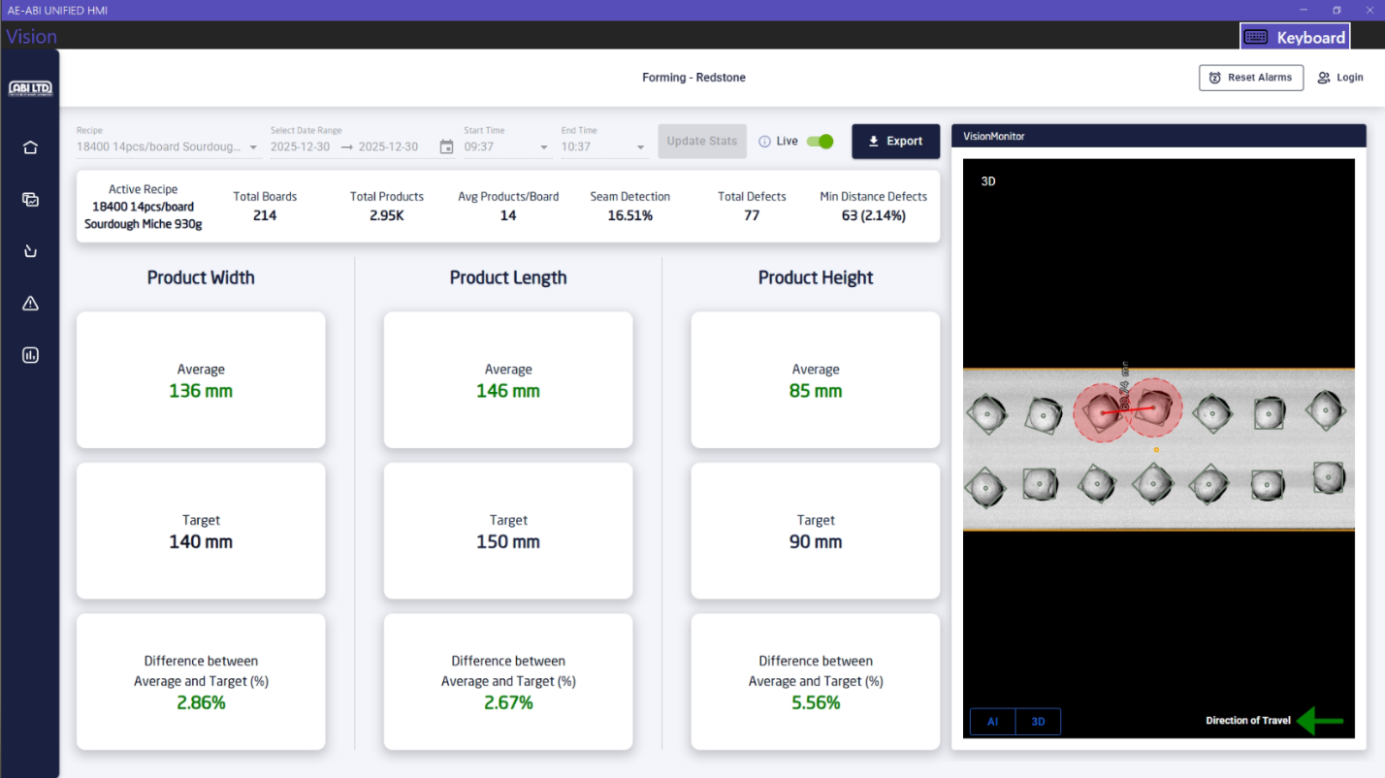

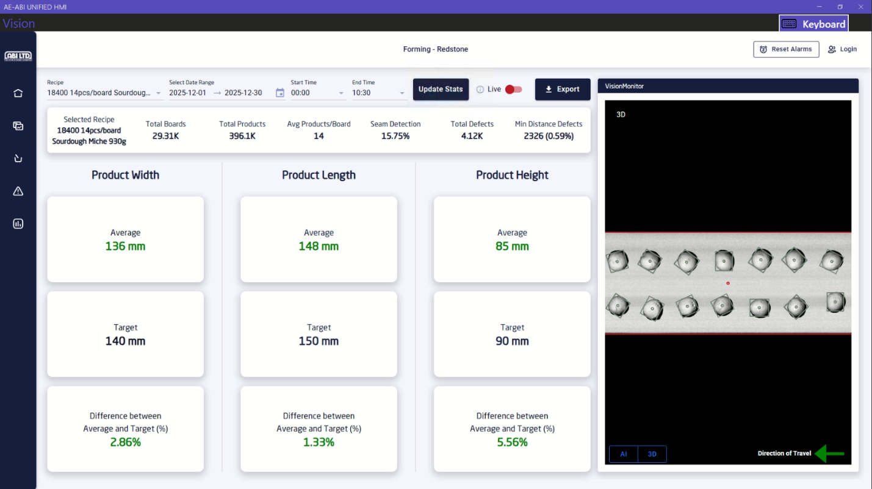

- Features
Depending on the node, some of the features are enabled on a specific node and some of them are not. Please find the list of features vs nodes in the table below.
Feature Name | Depositing | Proofer | Post Bake
Product measurements | Yes | Yes | Yes
Product count per board/scan | Yes | Yes | Yes
Seam detection | Yes | No | No
Straightness | Yes (available but disabled) | Yes | No
Grayscale analysis | No | No | Yes
Scoring presence | No | No | Yes
Last images (24h) | Yes | Yes | Yes
Minimum distance calculation between products | Yes | Yes | Yes

- Trends
The trends page of the application has different tabs based on specific EyeQ node. The filtering and live toggling works the same as the home page. Please find the description of all the tabs and the data each tab is displaying below.
- Measurements
The measurements tab shows the average width, length, and height of the products per board/per scan. As you can see from the screenshot below, the average width of products was 138 mm for the board scanned at 2025-12-30, 11:01:57 am. The charts can be zoomed in by selecting a portion and dragging on the HMI. The home icon can be pressed to reset the chart to default position.
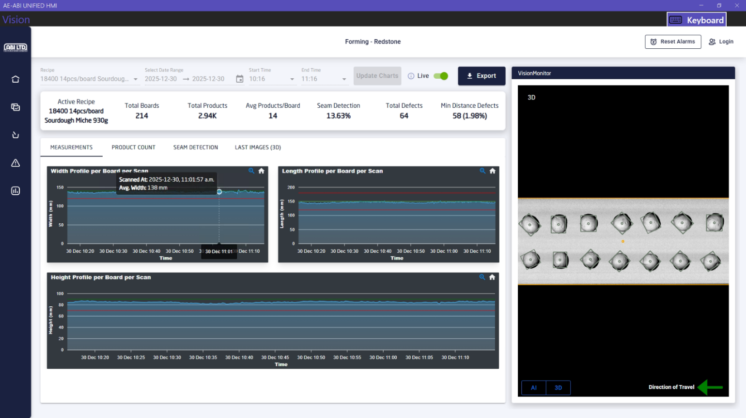

- Product Count
The product count tab shows the number of products per board/per scan. From the screenshot below, it can be seen that there were 13 products for the board scanned at 2025-12-30, 11:01:57 am.
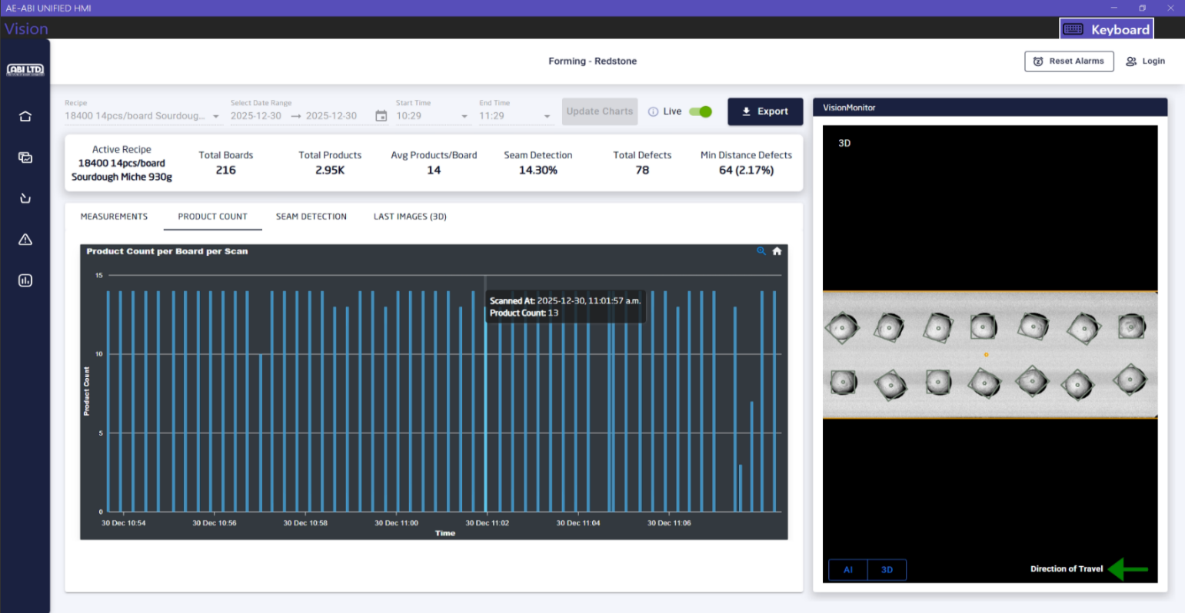
- Seam Detection
The seam detection tab shows the number of products with seam vs the number of products without seam in a bar chart as percentage per board/per scan. For example, in the screenshot below for the board scanned at 2025-12-30, 11:01:57 am, the percentage of products with seam was 15.38% meaning that among 13 products 2 of them had seam and the remaining 11 products did not have any visible seam.
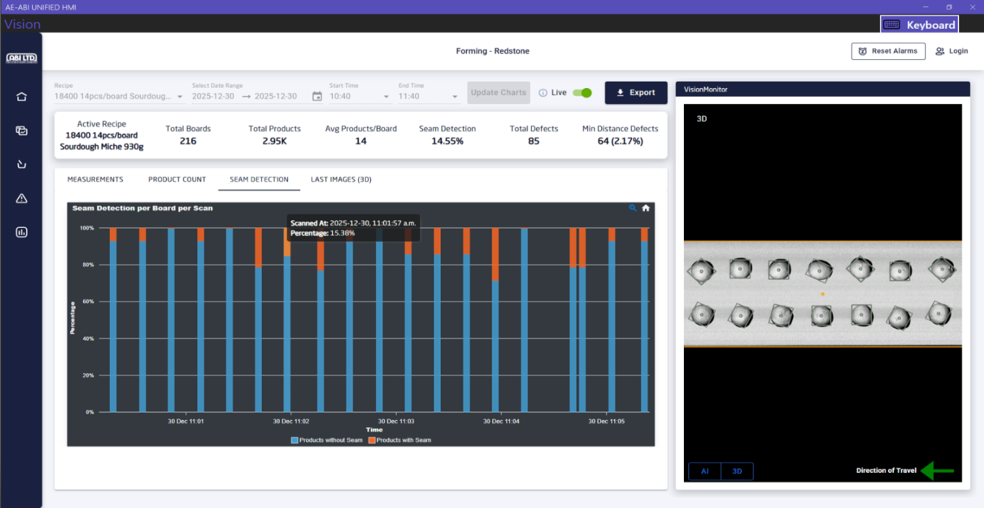
- Grayscale Analysis
The grayscale analysis tab shows the average grayscale values (0-255) for products per board/per scan. From the screenshot below, it can be seen that the average grayscale value was 141.90 for the products of the board scanned at 2025-12-30, 11:10:36 am. The chart also shows the different ranges for the grayscale values as a legend so that the user know which range is good, acceptable and not acceptable. These values are recipe specific, and they can be set in the Thresholds page for a recipe which will be discussed later in the document.
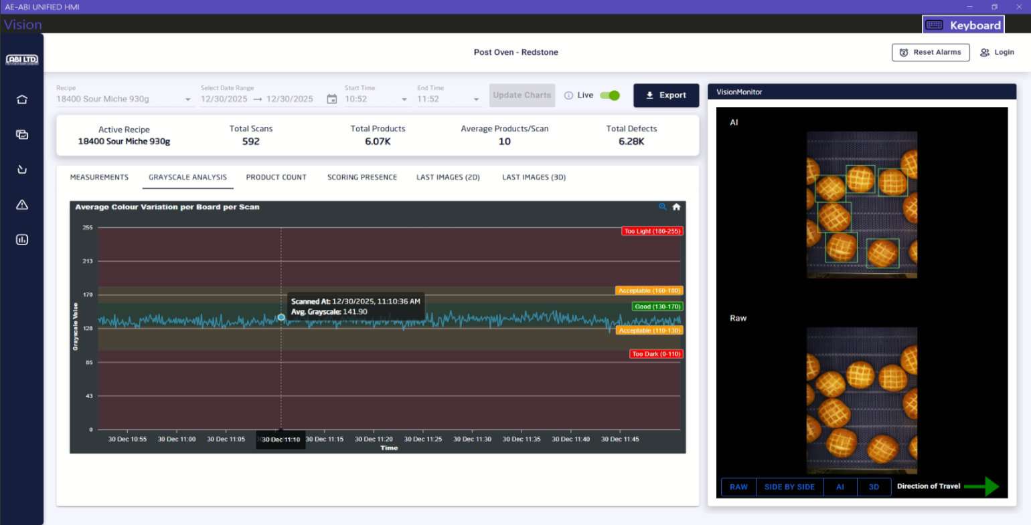
- Straightness
The product straightness tab shows the average ratio of product length over product width for products per board.
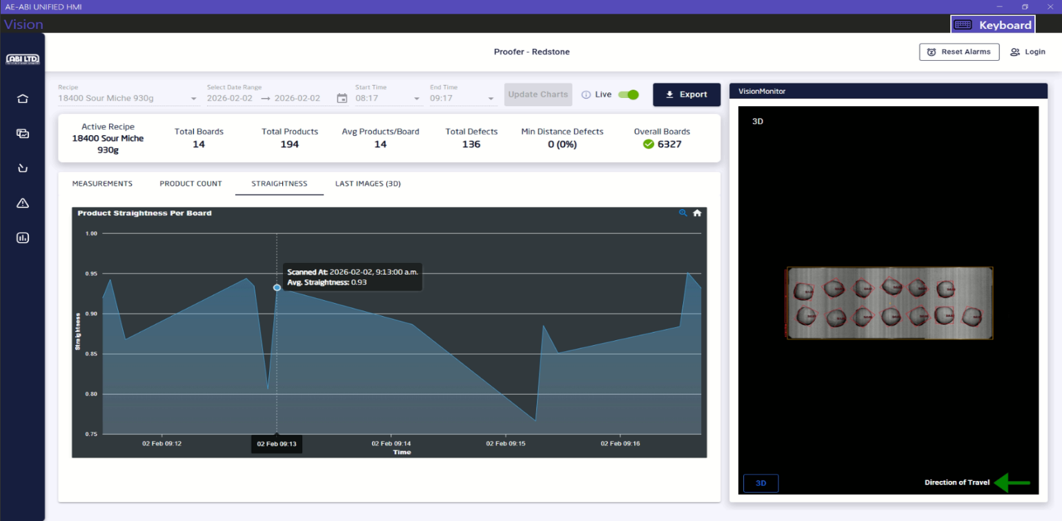
- Last Images
The last images (2D) and last images (3D) tabs show the images captured during the last 24 hours. The latest images are shown first and there is pagination support to view the previous images. It also shows the time when the image was capture and an image can be enlarged by clicking on it to view it more clearly. Please find the screenshots below.
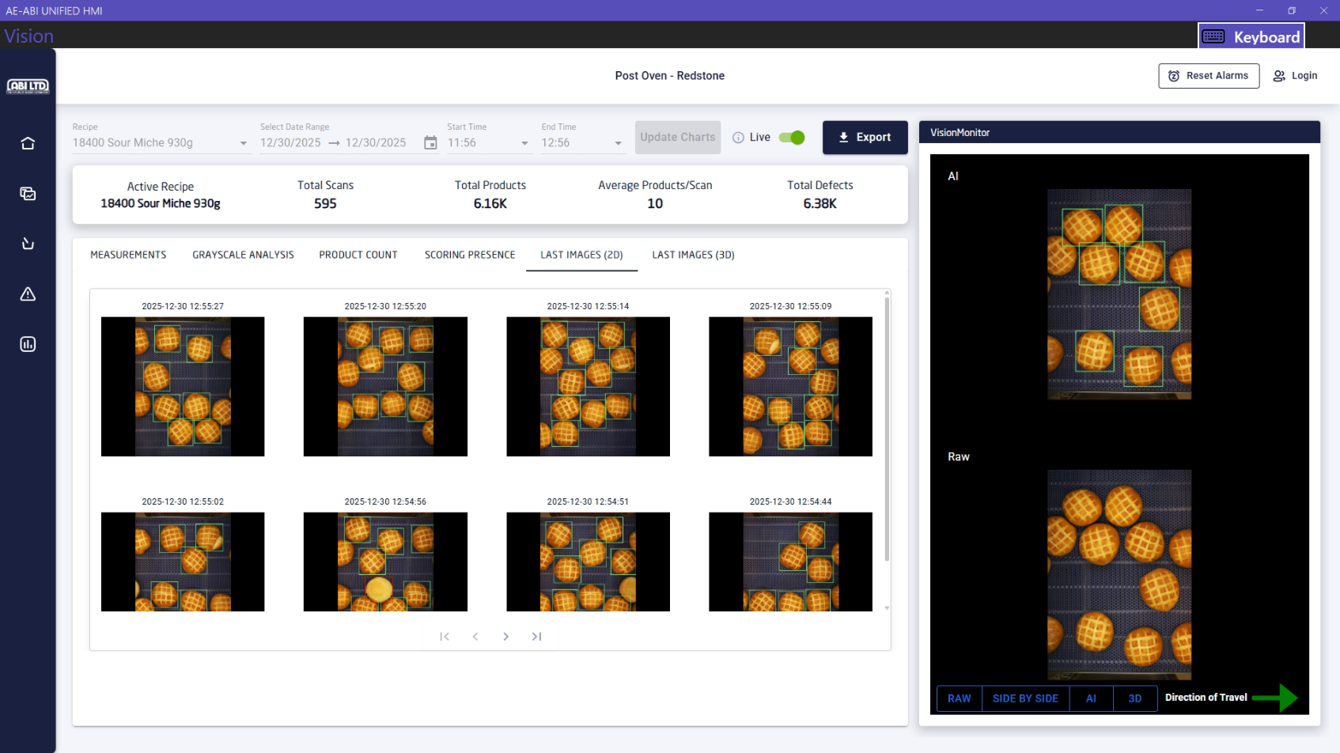

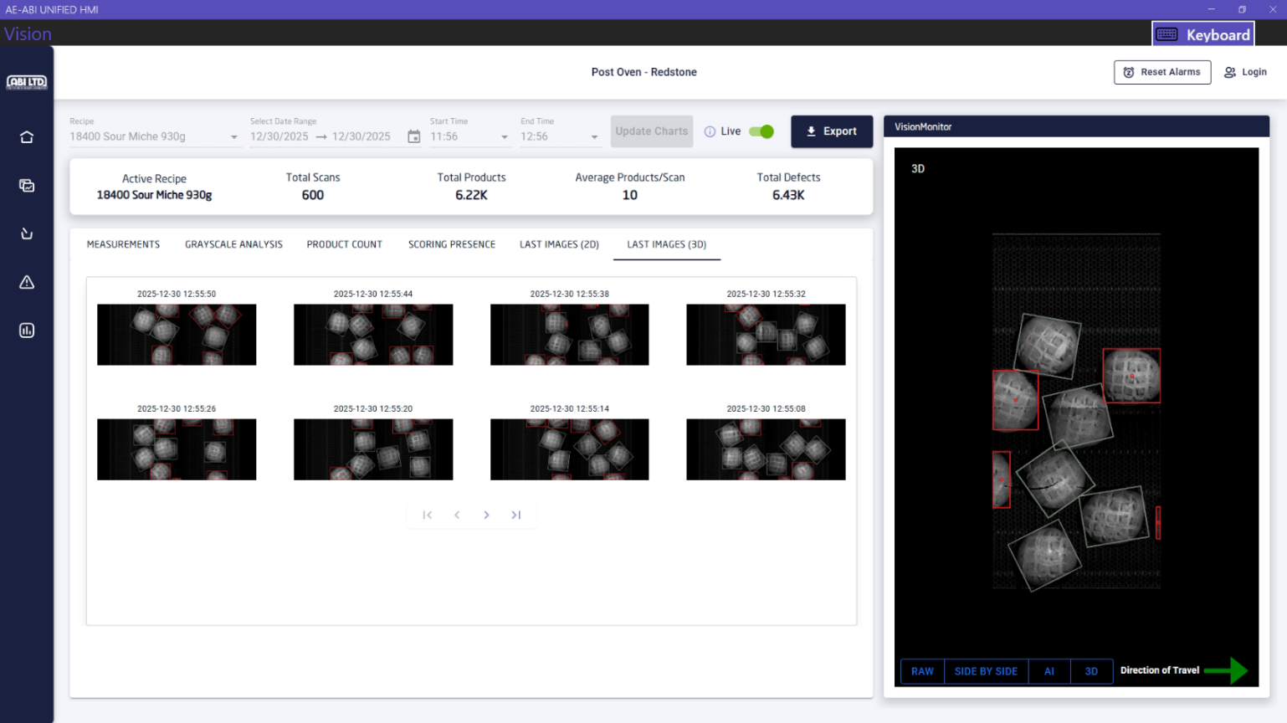
- Recipes
The recipes page shows all the recipes along with total number of products produced and number of products that had defects for each recipe since that recipe was active. It also shows the active recipe that is currently running with a darker blue background. Please look at the following two screenshots.

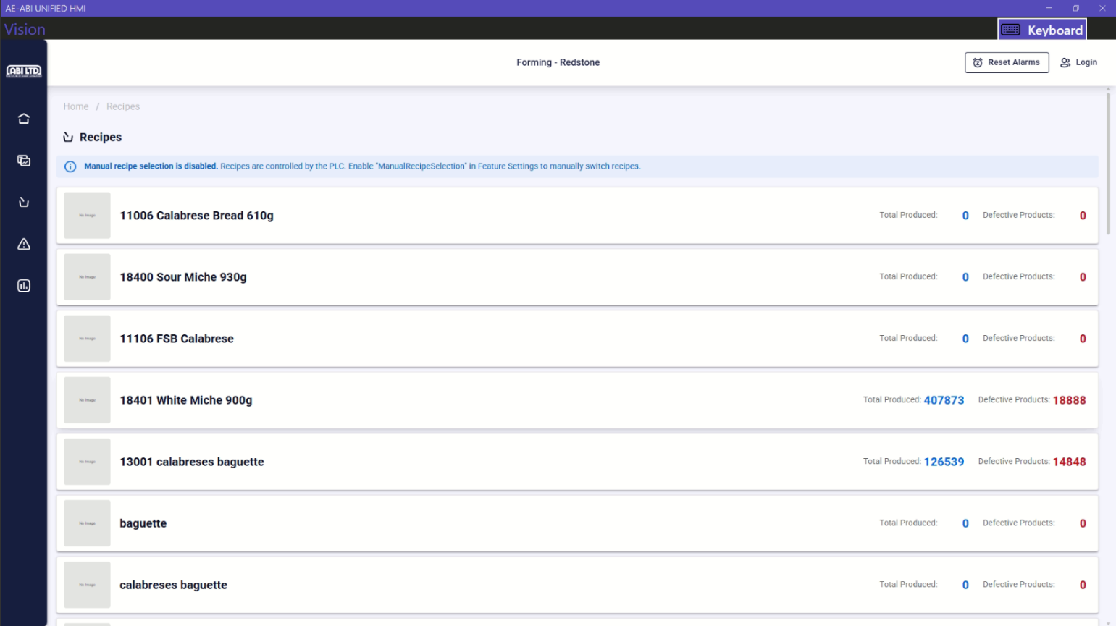

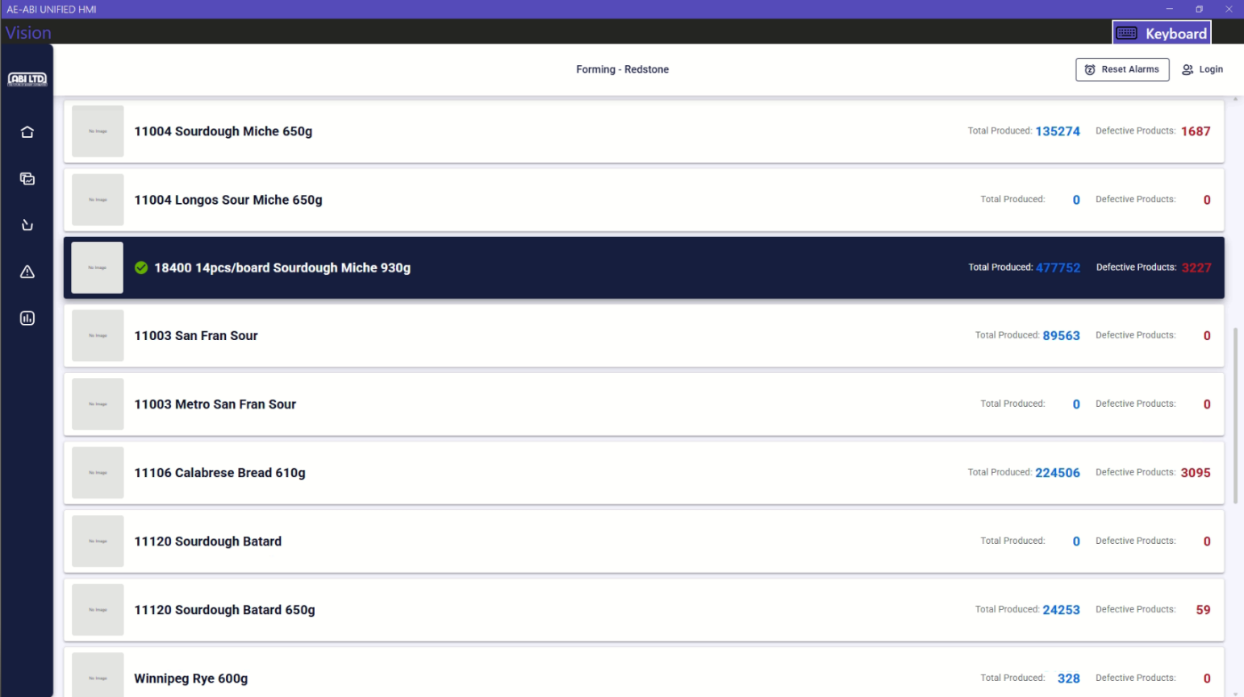

By default, the active recipe is set and controlled by the PLC. To enable recipe selection manually, go to Settings > Feature Settings and enable the “ManualRecipeSelection” feature.
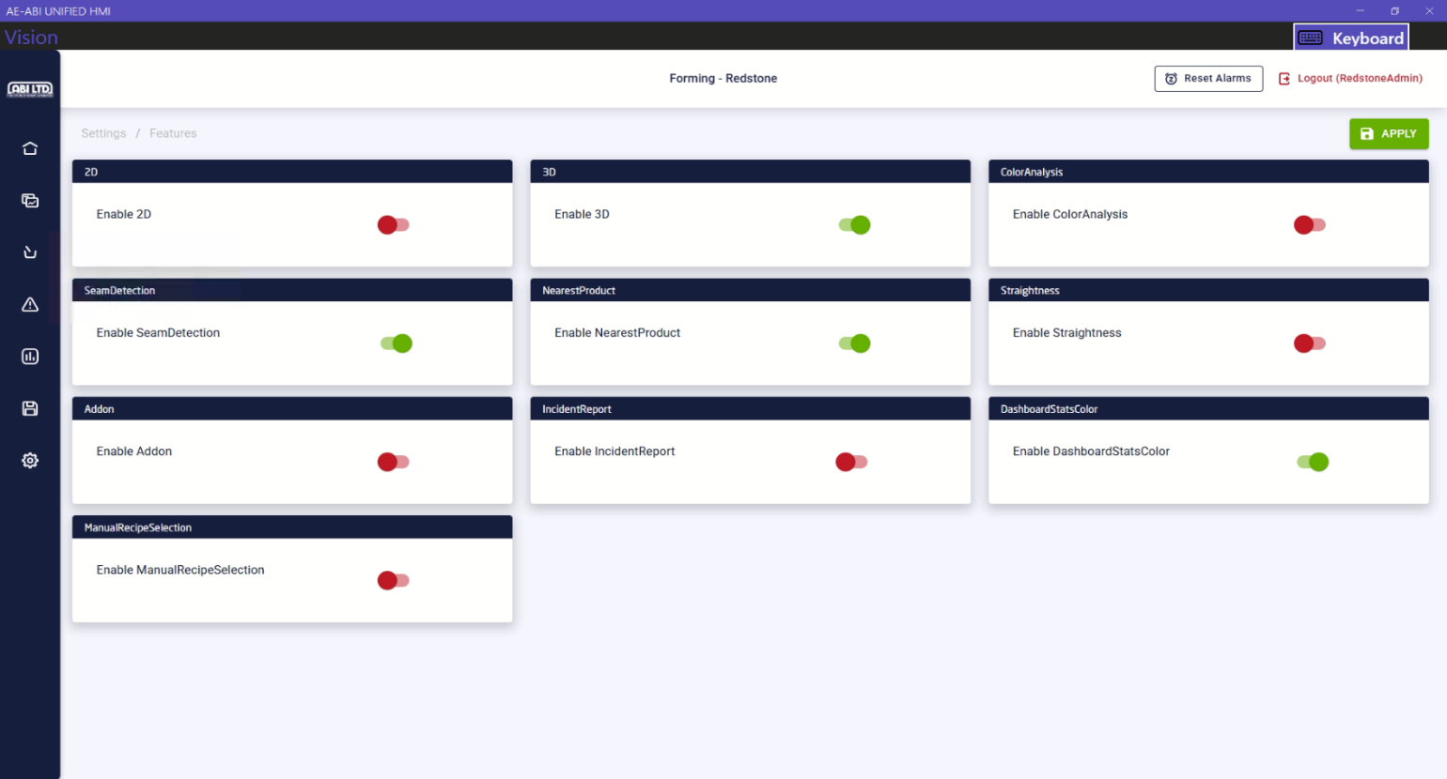

- Logs
The logs page shows the system logs and user action logs for the application along with any defects for products that were detected while processing the images. The user can click on the Clear Errors button at the right of the page to clear the errors.
The system logs can be filtered by severity and can be exported using the Export button.

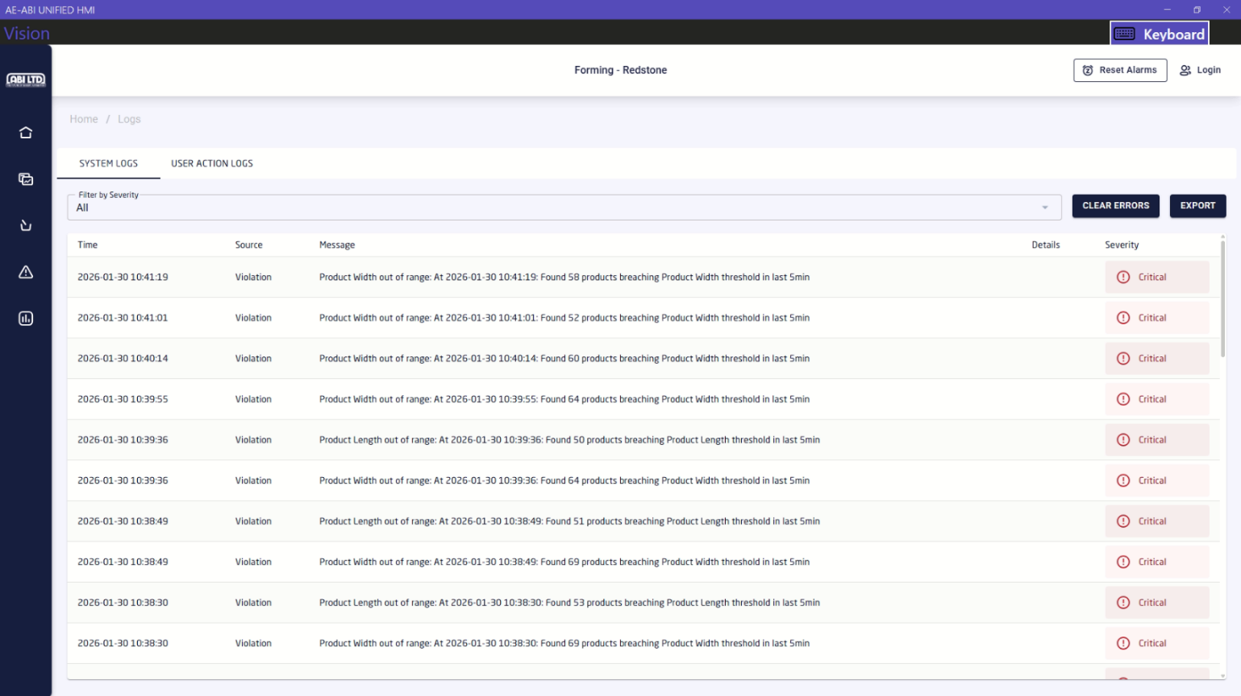

The user action logs show what actions were taken by a user while using the system such as login, logout time, changes in threshold for a recipe. These logs can be filtered by start and end date, user, and action. They can also be exported using the Export button.
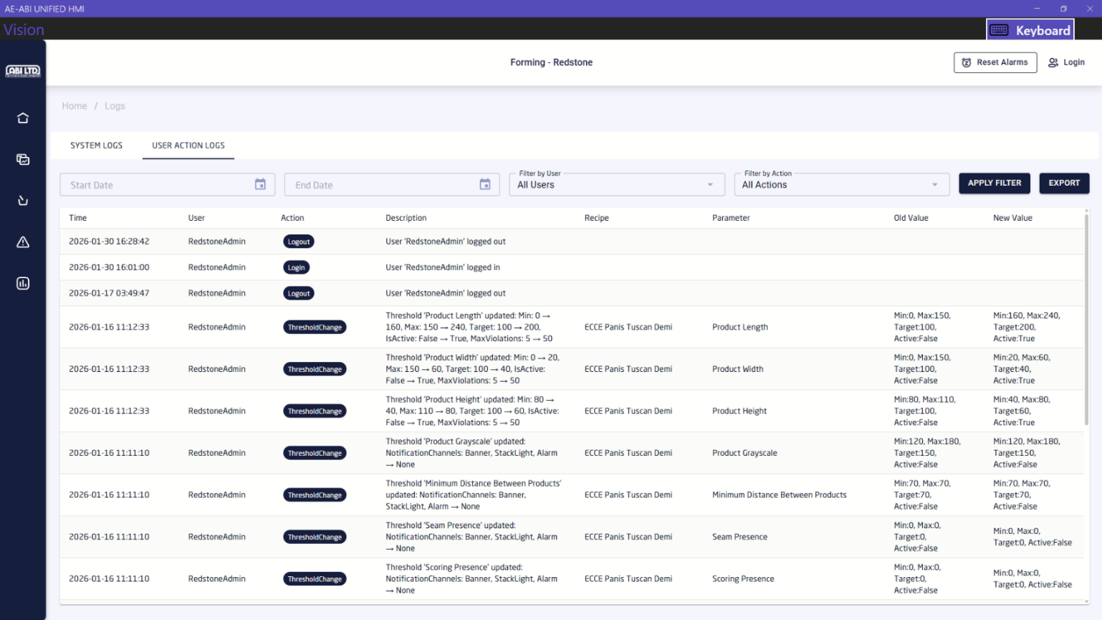

- Thresholds
The thresholds page shows the different types of thresholds that have been set up for the active recipe. There are 10 thresholds for now per each recipe based on the EyeQ node. They are Product Height, Product Width, Product Length, Straightness (ratio of product width vs length), Scoring Presence (if the product is scored), Seam Presence (if the product has seam), Minimum Distance Between Products, Products Per Board, Boards Per Hour and Product Grayscale. Each threshold has the following fields.
  - Name: Name of the threshold
  - Target: Target value for the threshold
  - Min: Minimum accepted value for the threshold
  - Max: Maximum accepted value for the threshold
  - Number of Defects: The number of defects that need to be passed before an alarm is raised
  - Defect interval (min): The amount of time the system will check to decide whether to raise an alarm. For example, if the number of defects is 50 and defect interval is 5 minutes then an alarm will be raised if in the last 5 minutes the number of defects for that specific threshold is 50 or higher
  - Message: The message that will be displayed in the alarm
  - Notify by: The notification channels (Banner, Stack light, Alarm buzzer) by which the user will be alerted. There is a Reset Alarms button at the top right of the screen which will reset all the alarms
  - Active: Whether or not the threshold is active for the recipe. The threshold must be active to log the defects in the system
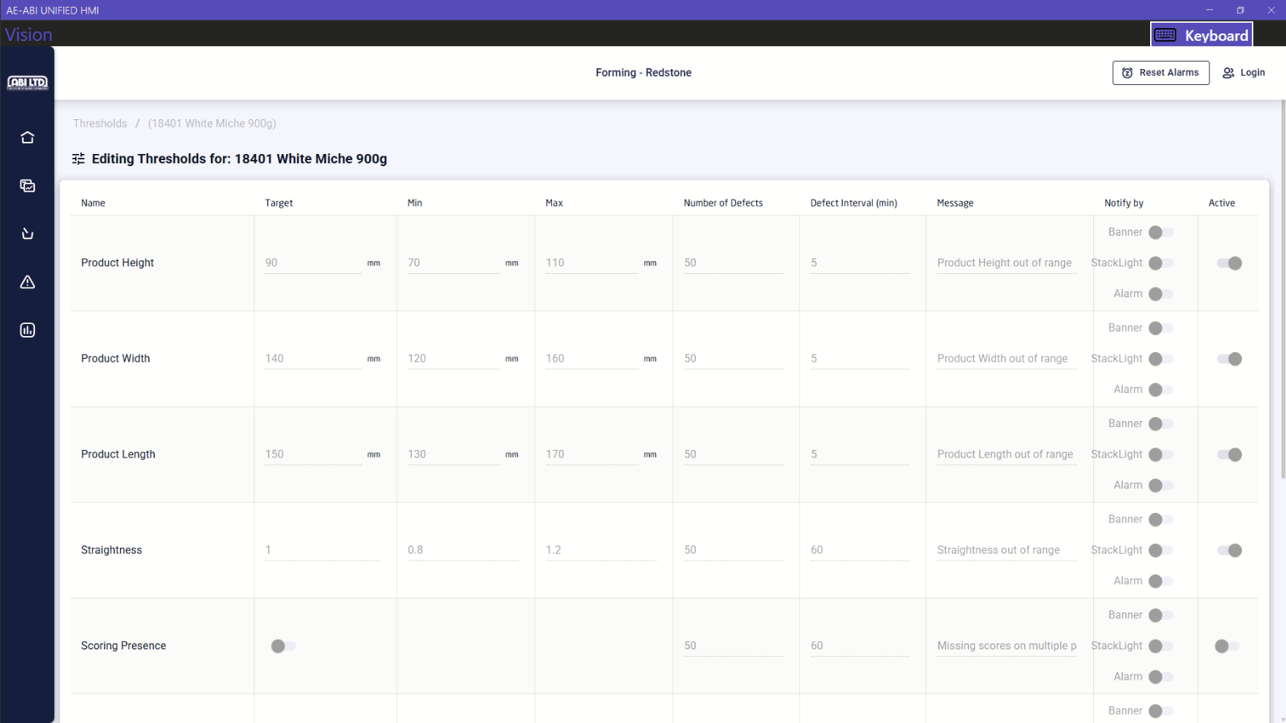
By default, the users/operators can only view the thresholds for the active recipe. To edit them, the user needs to login. The login method and threshold changing process will be described later in the document.
- Login
The Login button is located at the top-right of the application. To change threshold values, 3D settings for the camera, taking backups the user needs to login as Admin. The credentials for the admin user are provided below.
Username: RedstoneAdmin
Password: redstone@123
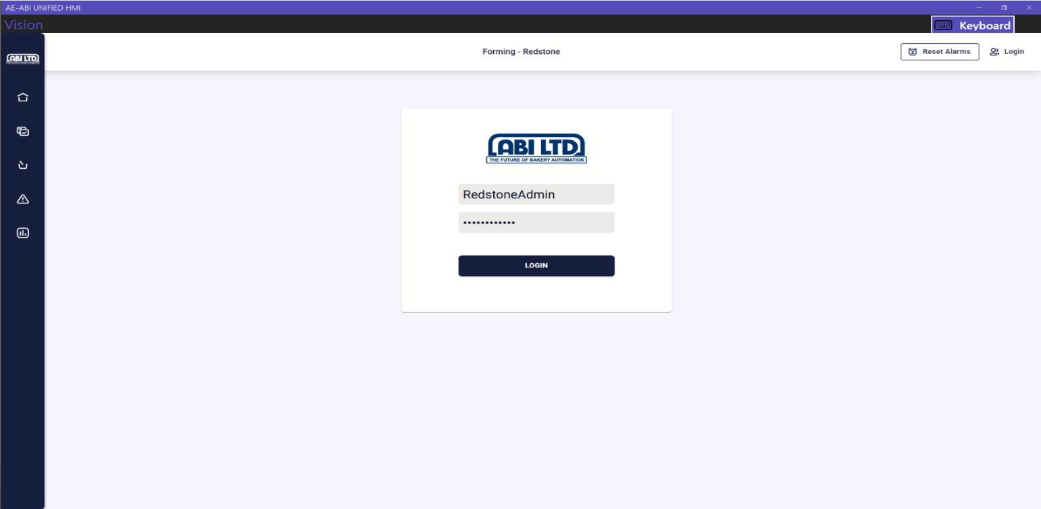
- General Settings
The general settings page will only appear once the user is logged in. Click on the Settings > General Settings tab to view the settings. Please look at the screenshots below.

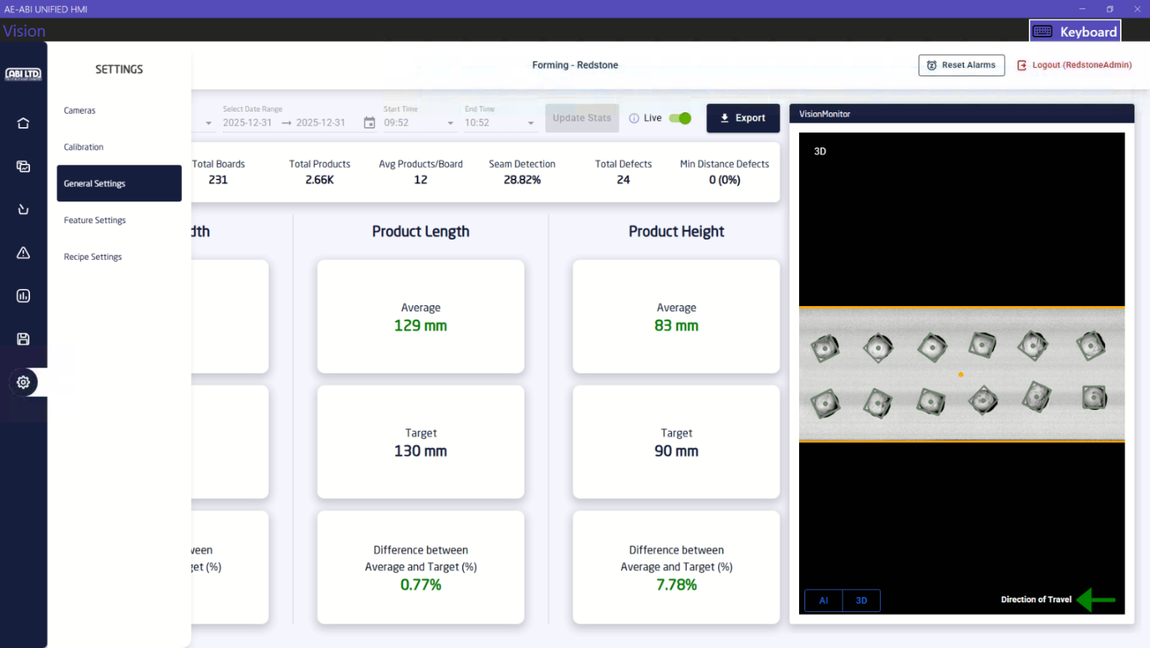

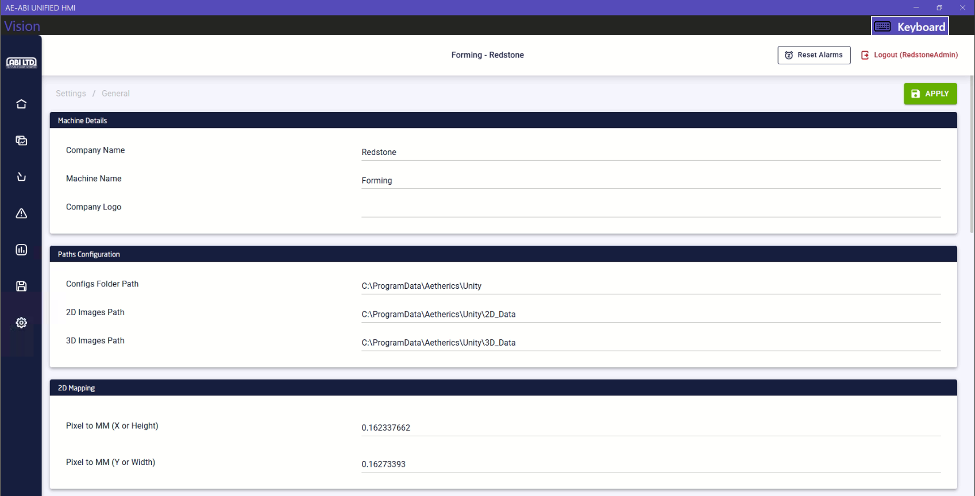

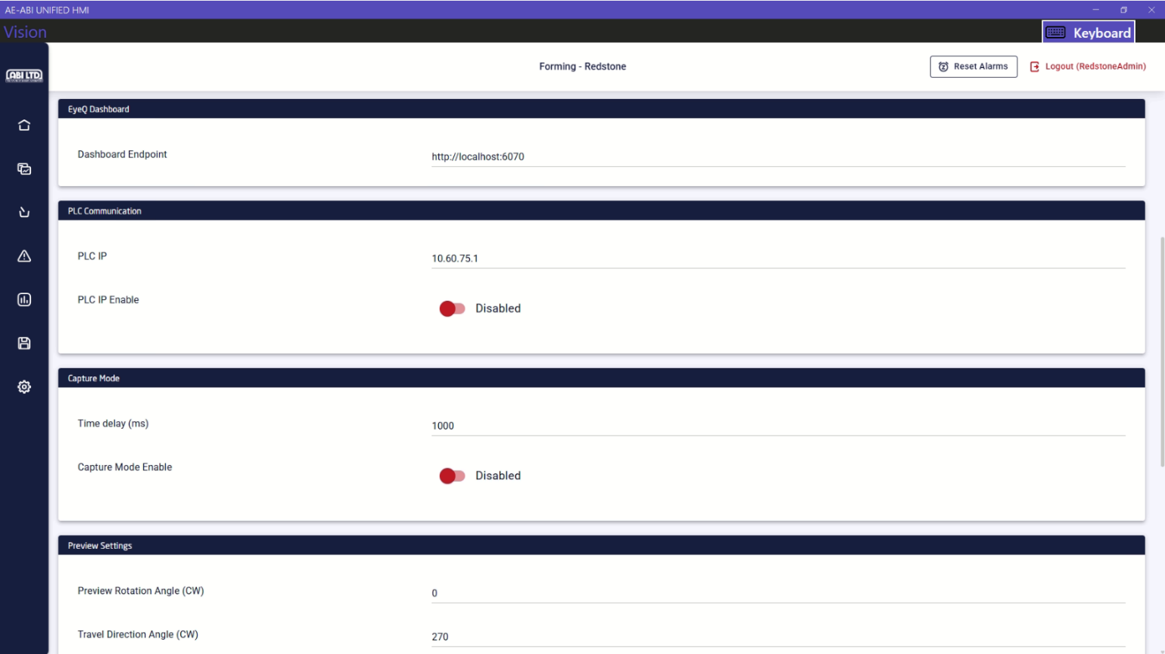

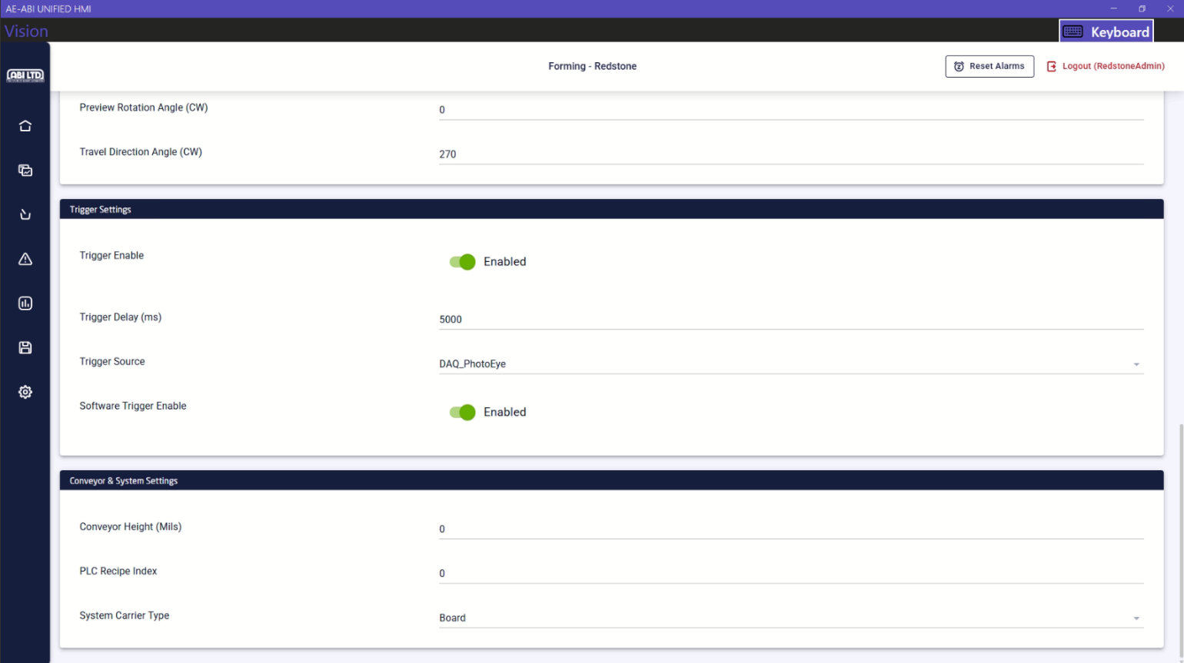

- Feature Settings
The feature settings page will only appear once the user is logged in. Click on the Settings > Feature Settings tab to view the settings. Please look at the screenshots below.

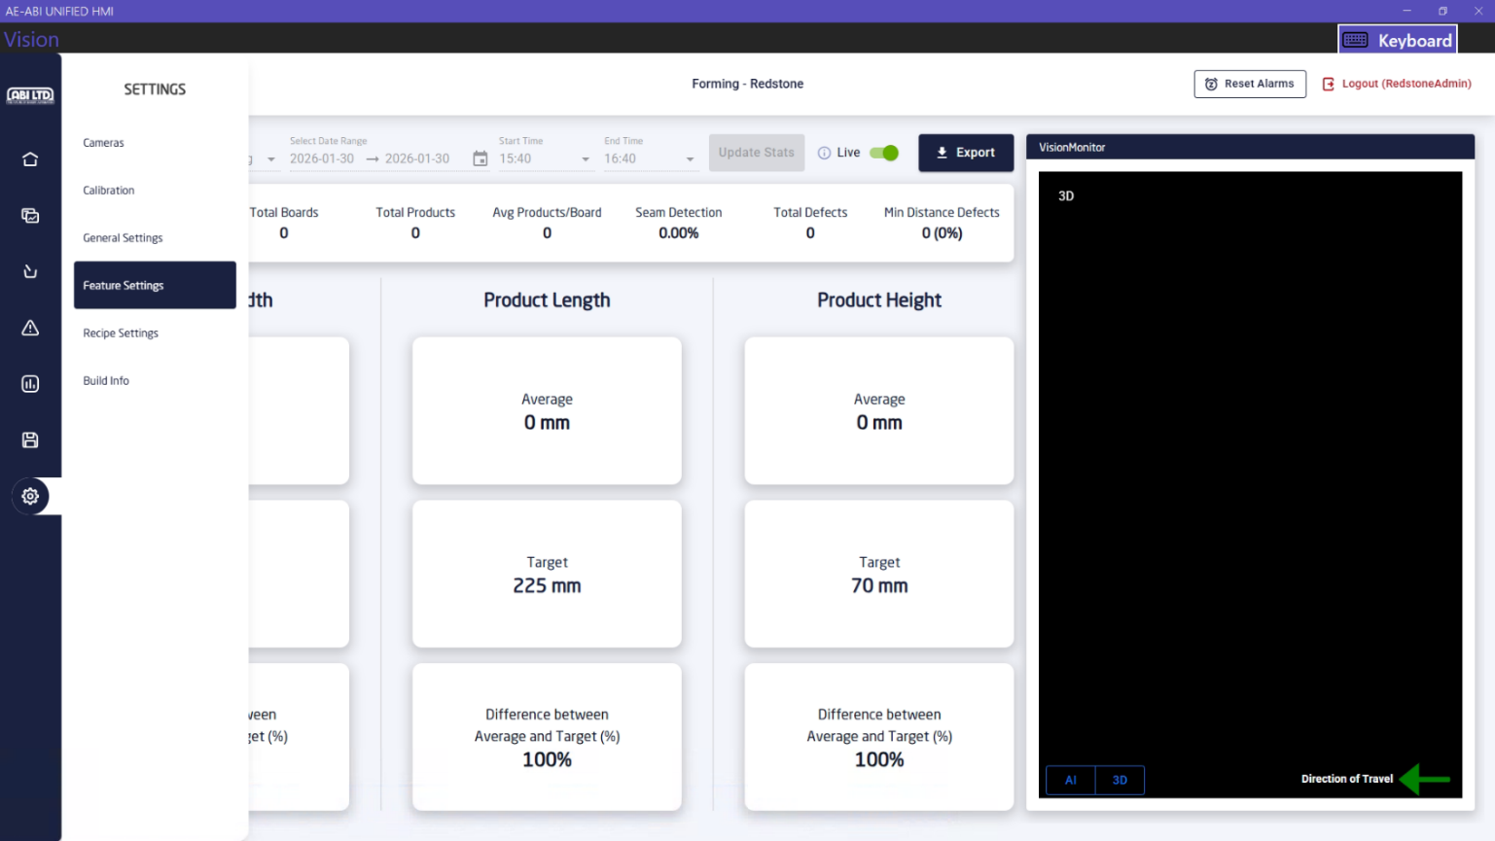

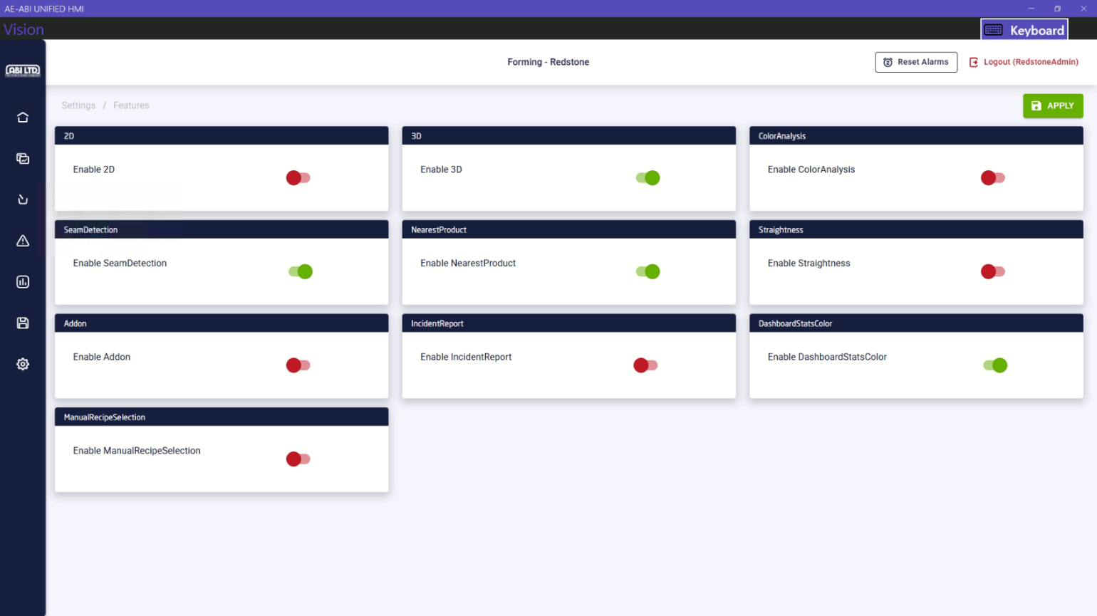

- Changing the thresholds on the recipes
- To change the thresholds for a recipe, login as Admin using the credentials above
- Click on the Settings > Recipe Settings > Edit Thresholds buttons for specific recipe, then set the values. After changing the thresholds, click on APPLY button to save the changes. Please find the screenshots below
